Secretary / Administrator Ms Alison Bone  2 The Derry  Ashton Keynes, Wilts SN6 6PW  Telephone: 01285 862377  Internet: wwwbembtrust.org.uk  Email: alibone@bembtrust.org.uk | 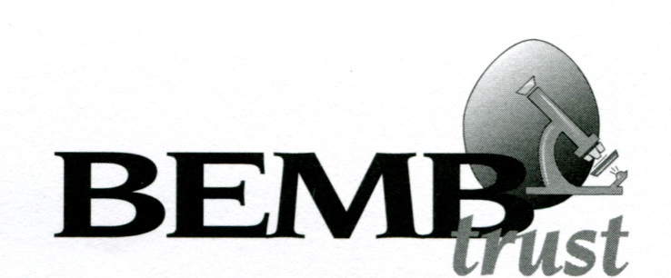
 | Chairman Dr Martin W. Shirley, CBE., PhD., BSc., FSB., CBiol., FRAgS., Hon. Assoc. RCVS.

21 May 2021

Dear Research Institution

INVITATION TO SUBMIT APPLICATIONS FOR POST GRADUATE SCHOLARSHIPS IN POULTRY RESEARCH FROM OCTOBER 2022

It is the policy of the British Egg Marketing Board Research and Education Trust to fund Post Graduate Awards every other year for research into projects relating to commercial hen or duck egg production. Each Award is for a period of 4 years and sponsorship is based upon BBSRC rates. The Trust is now looking for appropriate projects to commence in October 2022.

If you would like to discuss the appropriateness of a proposal before submission, feel free to contact Trust Chairman, Dr Martin Shirley, CBE of the BEMB Research and Education Trust on 01480 811703 or martinshirley@btinternet.com

The objective of the Trustees is to act as a catalyst in providing good young poultry scientists for the future. PhD applications and other projects are judged based on good science and an appreciation of current egg production problems.

An application form for PhD Projects is attached. Online submission is welcomed but if you wish to receive a paper copy of this letter and application form please contact me at alibone@bembtrust.org.uk and I will be very happy to post out hard copies. Please note that completed forms need to be received by 20 September 2021 and this date will be strictly adhered to. All applicants will be notified of the result of their applications by end of November 2021.

If you think any of your colleagues may be interested, please be kind enough to forward this document. I would welcome any amendments to my circulation list that you may care to notify.

Yours sincerely

Alison Bone

Secretary

